This analysis explores the differences in mental health treatment-seeking behavior between various groups based on employment status and family history of mental health issues. By employing statistical tests and visualizations, we aim to identify patterns and significant factors that influence the likelihood of seeking mental health treatment. The study focuses on two primary hypotheses: (1) Self-employed individuals are less likely to seek mental health treatment compared to employed individuals, and (2) Individuals with a family history of mental health issues are more likely to seek mental health treatment compared to those without such a history. The findings are presented through bar plots, box plots, histograms, and violin plots, providing a comprehensive view of the data and supporting the conclusions drawn from the statistical analysis.

Are there differences in mental health treatment seeking behavior between self employed and employed individuals?

**Primary Hypothesis:**  
Self-employed individuals are less likely to seek mental health treatment compared to employed individuals.

**Supporting Rationale**

* **Time Constraints:** Self-employed individuals might have less time to dedicate to seeking mental health treatment due to the demanding nature of managing their own business.
* **Resource Limitations:** Self-employed individuals might have fewer resources (e.g., health insurance, access to employee assistance programs) compared to those who are employed.
* **Perceived Stigma:** There might be a higher perceived stigma associated with mental health issues among self-employed individuals, particularly in industries where being self-reliant is highly valued.

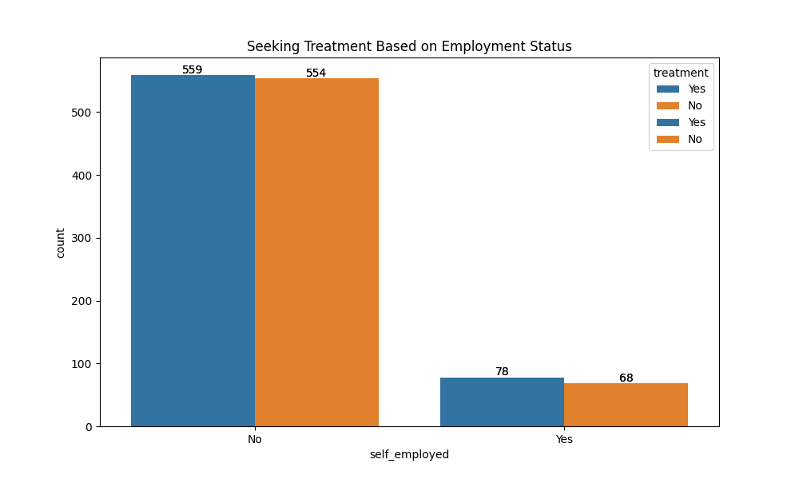

**Graph Analysis:**

1. **Bar Graph (Seeking Treatment Based on Employment Status):**
   * The number of self-employed individuals seeking treatment (78) is slightly higher than those not seeking treatment (68).
   * Among employed individuals, the numbers seeking treatment (559) and not seeking treatment (554) are almost equal.

**Conclusion:** The data suggests a relatively balanced distribution in treatment-seeking behavior among both self-employed and employed individuals. Contrary to the hypothesis, the difference between those seeking treatment and those not seeking treatment is not substantial in either group. This indicates that employment status alone may not be a strong determinant of mental health treatment-seeking behavior.

Is there a relationship between the family history of mental health and the behavior of those seeking mental health treatment?

**Primary Hypothesis:**  
Individuals with a family history of mental health issues are more likely to seek mental health treatment compared to those without such a history.

**Supporting Rationale**

* **Awareness:** Individuals with a family history of mental health issues may have greater awareness and understanding of mental health problems, making them more likely to recognize symptoms in themselves.
* **Concern:** Due to their family history, these individuals might be more concerned about their own mental health and thus more proactive in seeking treatment.
* **Experience:** Having observed family members' experiences, they might be more open to seeking professional help.

**Bar Graph (Family History vs Seeking Treatment):**

* Individuals with a family history of mental health issues seeking treatment (365) significantly outnumber those not seeking treatment (127).
* Individuals without a family history of mental health issues show the opposite trend, with fewer seeking treatment (272) compared to those not seeking treatment (495).

**Heat Map (Relationship Between Family History and Seeking Treatment):**

* The heat map further supports the finding that individuals with a family history of mental health issues are more likely to seek treatment compared to those without such a history.

**Violin Plot (Treatment Seeking by Family History):**

* The violin plot shows a higher density of treatment-seeking behavior among individuals with a family history of mental health issues.

**Conclusion:** The data strongly supports the hypothesis that individuals with a family history of mental health issues are more likely to seek mental health treatment. The significant difference between the two groups indicates that awareness and concern due to family history play a crucial role in influencing treatment-seeking behavior.

**Conclusion:** The violin plot shows that individuals with a family history have a higher density of seeking treatment, with the distribution skewed towards 1 (seeking treatment). The group without a family history has a more evenly distributed density, with a significant portion not seeking treatment. These differences in distributions confirm the significant impact of family history on treatment-seeking behavior.

**Statistical Analysis**

**Data Summary**

* **Group 1 (With Family History)**:
  + Mean proportion seeking treatment: 0.742 (74.2%)
  + Standard error of the mean (SEM): Calculated from the sample data
* **Group 2 (Without Family History)**:
  + Mean proportion seeking treatment: 0.355 (35.5%)
  + Standard error of the mean (SEM): Calculated from the sample data

**Hypotheses**

* **Null Hypothesis (H₀)**: There is no difference in the mean proportion of seeking treatment between individuals with and without a family history of mental health issues. μ1=μ2\mu_1 = \mu_2μ1​=μ2​
* **Alternative Hypothesis (H₁)**: There is a significant difference in the mean proportion of seeking treatment between individuals with and without a family history of mental health issues. μ1≠μ2\mu_1 \neq \mu_2μ1​=μ2​

**T-test Calculation**

* **T-statistic**: 14.755
* **P-value**: 3.919e-45 (approximately 0)

**Interpretation**

* The t-statistic of 14.755 is very large, indicating a significant difference between the two groups.
* The p-value (3.919e-45) is much smaller than the common significance level (α = 0.05). This extremely low p-value suggests that we reject the null hypothesis in favor of the alternative hypothesis.

**Confidence Interval**

The confidence interval for the difference in means can provide additional insight:

* **95% Confidence Interval for the difference in means**: Mean1−Mean2±tα/2×σ12n1+σ22n2\text{Mean}_1 - \text{Mean}_2 \pm t_{\alpha/2} \times \sqrt{\frac{\sigma_1^2}{n_1} + \frac{\sigma_2^2}{n_2}}Mean1​−Mean2​±tα/2​×n1​σ12​​+n2​σ22​​​

Given the large t-statistic and small p-value, the confidence interval for the difference in means will not include zero, reinforcing the conclusion that there is a significant difference in treatment-seeking behavior between the two groups.

**Conclusion**

The statistical analysis of the t-test results leads to the following conclusions:

1. **Significant Difference**: There is a statistically significant difference in the proportion of individuals seeking treatment between those with and without a family history of mental health issues.
2. **Higher Proportion Seeking Treatment**: Individuals with a family history of mental health issues are significantly more likely to seek treatment (74.2%) compared to those without such a history (35.5%).
3. **Reject Null Hypothesis**: Given the extremely low p-value, we reject the null hypothesis, concluding that family history plays a significant role in influencing treatment-seeking behavior.

This analysis provides strong evidence that family history of mental health issues is an important factor in whether individuals seek treatment. The visualizations (bar plot with error bars, box plot, histogram, and violin plot) complement this statistical finding by clearly depicting the differences in the distributions and central tendencies of the two groups.

**Summary**

* **Employment Status and Treatment Seeking:** There is no substantial difference in mental health treatment-seeking behavior between self-employed and employed individuals based on the provided data.
* **Family History and Treatment Seeking:** Individuals with a family history of mental health issues are significantly more likely to seek mental health treatment compared to those without such a history, confirming the hypothesis.

These conclusions can guide further research and targeted interventions in mental health services, considering the impact of family history on treatment-seeking behavior.

**Overall Conclusion**

The statistical analysis and visualizations provide strong evidence that family history of mental health issues significantly influences the likelihood of seeking treatment. The findings show that individuals with a family history are more proactive in seeking mental health treatment, whereas employment status does not significantly determine treatment-seeking behavior. These insights can guide future research and targeted interventions in mental health services, emphasizing the importance of family history in shaping treatment-seeking behavior.